**“In Pursuit of Technical Excellence**

A Seminar Report on

Introduction to Web Analytics

For The Degree of

**MASTER OF COMPUTER APPLICATION**

Submitted by

**_______________**

**(MC23F14F0__)**

Under the guidance of

**Dr. Avinash K. Gulve**



Department of Master of Computer Application

**Government College of Engineering, Aurangabad**

**(An Autonomous Institute of Government of Maharashtra)**

**(2024-2025)**

**CERTIFICATE**

This is to certify that the seminar report on ____________ which is being submitted by _______________________ Enrollment No. **MC23F14F0__** is a bonafide work completed under my supervision and guidance, in partial fulfillment for award of the degree of “**Master of Computer Application**” of Government Engineering College, Aurangabad (An Autonomous Institute of Government of Maharashtra) affiliated to Dr. Babasaheb Ambedkar Marathwada University, Aurangabad

**Date - 24/10/2024**

**Place - Aurangabad**

Dr. Avinash K. Gulve

Seminar Guide Head

MCA Department MCA Department

Dr. Sanjay Dambhare

Principal

Government College of Engineering,

Aurangabad

Chhatrapati Sambhajinagar.

**ACKNOWLEDGEMENT**

Submitted by:

**_____________ _______ (MC23F14F0__**)

|  |  |  |  |
| --- | --- | --- | --- |
| Sr. No. | Topic | | Page Number |
| i. | Figure index | | i |
| ii. | Table index | | ii |
| 1 | Introduction | | 1 |
|  | 1.1 | The Importance of Web Analytics in Business | 1 |
|  | 1.2 | The Evolution of Web Analytics Tools | 2 |
|  | 1.3 | Key Metrics and Concepts in Web Analytics | 4 |
|  | 1.4 | Challenges in Web Analytics | 5 |
| 2 | Evolution of Web Analytics | | 6 |
|  | 2.1 | Early days of Web Analytics | 6 |
|  | 2.2 | The Introduction and Impact of Google analytics | 6 |
|  | 2.3 | Event based and behavioural Analytics | 7 |
|  | 2.4 | User Analytics and Machine Learning | 8 |
|  | 2.5 | Predictive Analytics and Machine Learning | 9 |
|  | 2.6 | Privacy-Focused Analytics | 11 |
| 3 | Implementing Web Analytics Tools | | 12 |
|  | 3.1 | Selecting the Right Analytics Tool | 12 |
|  | 3.2 | Setting Up the Analytics Tool | 14 |
|  | 3.3 | Analyzing the Data | 15 |
|  | 3.4 | Deriving Actionable Insights | 16 |
| 4 | Implementing Web Analytics Tools | | 19 |
|  | 4.1 | Selecting the Right Analytics Tool | 19 |
|  | 4.2 | Setting Up Web Analytics Tools | 20 |
|  | 4.3 | Best Practices for Using Web Analytics Tools | 21 |
|  | 4.4 | Challenges in Implementing Web Analytics Tools | 22 |
| 5 | Future Trends in Web Analytics | | 24 |
|  | 5.1 | Artificial Intelligence and Machine Learning | 24 |
|  | 5.2 | Increased Focus on Privacy and Data Security | 26 |
|  | 5.3 | Real-Time Analytics | 27 |
|  | 5.4 | Integration of Cross-Channel Data | 28 |
|  | 5.5 | Emerging Trends in Data Visualization | 29 |
| 6 | Practical Applications of Web Analytics | | 31 |
|  | 6.1 | Implementing a Web Analytics Strategy | 31 |
|  | 6.2 | Key Performance Indicators (KPIs) | 33 |
|  | 6.3 | Case Studies of Successful Web Analytics Implementation | 34 |
|  | 6.4 | Best Practices for Web Analytics | 35 |
| 7 | The Future of Web Analytics | | 37 |
|  | 7.1 | Emerging Trends in Web Analytics | 37 |
|  | 7.2 | Technologies Shaping the Future of Web Analytics | 39 |
|  | 7.3 | Preparing for the Future | 41 |
|  | Conclusion | | 43 |
|  | References | | 44 |

**Index**

**Figure Index**

|  |  |  |
| --- | --- | --- |
| Fig. No. | Caption of the figure | Page No |
| 1. | How Product Sales works | 3 |
| 2. | Financial KPI Dashboard. | 5 |
| 3. | Key Performance Indicator (KPI’s). | 7 |
| 4. | Telegram bot analytics with Mixpanel. | 9 |
| 5. | Adobe analytics unveils data analytic tools. | 10 |
| 6. | Matomo analytics showing page perfomance reports. | 10 |
| 7. | Analytical Tools. | 14 |
| 8. | A/B Testing. | 17 |
| 9. | Importance of Personalization in Data Analytics. | 17 |
| 10. | Predictive Analytics Techniques. | 24 |
| 11. | Predictive Analytics Process. | 25 |
| 12. | Applications of Natural Language Processing | 25 |
| 13. | Benefits Of Artificial Intelligence. | 26 |
| 14. | Interactive Dashboard. | 29 |
| 15. | Augmented Reality(AR) and Virtual Reality(VR). | 30 |
| 16. | Storytelling with data. | 36 |
| 17. | Best Practices for Web Analytics. | 39 |
| 18. | Emerging trends for Web Analytics. | 39 |
| 19. | Web Analytics Market Growth Revenue. | 42 |

**Table Index**

|  |  |  |
| --- | --- | --- |
| Table No. | Caption of the Table | Page No |
| 1. | Features of Mixpanel And Heap. | 8 |

**Chapter 1: Introduction to Web Analytics**

In today’s digital age, businesses rely heavily on the internet as a primary platform for engaging with customers and driving growth. The success of a business’s online presence hinges not only on the volume of visitors it attracts but also on the ability to understand, analyze, and act on data gathered from user interactions. This is where web analytics becomes essential. Web analytics is the process of collecting, measuring, and analyzing web data to understand user behavior and optimize website performance. With the rise of e-commerce, digital marketing, and the importance of user experience (UX), web analytics has become indispensable for organizations looking to improve their online effectiveness. By analyzing key metrics, businesses can make data-driven decisions that improve user satisfaction and, ultimately, lead to higher conversion rates and profitability [1][2].

**1.1 The Importance of Web Analytics in Business**

In the modern business environment, data is often referred to as the "new oil." However, without proper tools and methods to process and analyze data, its value remains untapped. Web analytics serves as the bridge between raw data and actionable insights. The following points outline why web analytics is crucial for businesses today:

* **Understanding User Behaviour**: Web analytics provides insights into how users interact with a website. By examining metrics such as page views, session duration, and navigation paths, businesses can identify popular content, pain points, and the overall user journey. This data is instrumental in optimizing websites to provide a more user-friendly experience, thus increasing customer satisfaction and engagement. For instance, identifying which pages have high bounce rates or low engagement can prompt companies to improve those areas [2][4].
* **Optimizing Marketing Strategies**: With the help of web analytics, businesses can track the performance of their marketing campaigns. For instance, if a business runs an email marketing campaign, web analytics tools can reveal how many recipients clicked on the link, how long they stayed on the website, and whether they completed a desired action, such as making a purchase or signing up for a newsletter. This information allows businesses to refine their marketing strategies and focus on the most effective channels [5][6].
* **Measuring Key Performance Indicators (KPIs)**: Every business has specific goals and objectives. KPIs, such as conversion rates, return on investment (ROI), and customer retention rates, are metrics that businesses track to assess whether they are meeting their goals. Web analytics tools allow businesses to measure these KPIs accurately, providing a clear picture of performance and areas needing improvement [3][5].
* **Enhancing Customer Experience**: By identifying patterns in user behavior, businesses can personalize and enhance the customer experience. For example, if analytics reveal that a large percentage of users abandon their shopping carts before completing a purchase, the business can investigate and address any issues in the checkout process, such as simplifying the payment options or reducing the number of required steps. Improving these aspects leads to higher conversion rates and better user retention [2][4].

**1.2 The Evolution of Web Analytics Tools**

Web analytics has come a long way since the early days of the internet. Initially, businesses relied on simple tools to track basic metrics such as page views and visitor counts. However, as the internet expanded and user behavior became more complex, the need for advanced analytics grew. Today, modern web analytics tools offer a wide range of features that allow businesses to track detailed user interactions, from click-through rates to heatmaps and session recordings.

**1.2.1 Early Web Analytics**

In the early 1990s, as websites started to become mainstream, the first web analytics tools were developed. These tools primarily focused on measuring web traffic. One of the most popular metrics at the time was the **hit counter**, which displayed the number of visitors a website received. However, these tools offered limited insights and didn’t provide businesses with the level of detail needed to improve their digital strategies. For instance, while they could measure the number of visitors, they couldn’t track where these visitors were coming from or what actions they took while on the site [1][6].

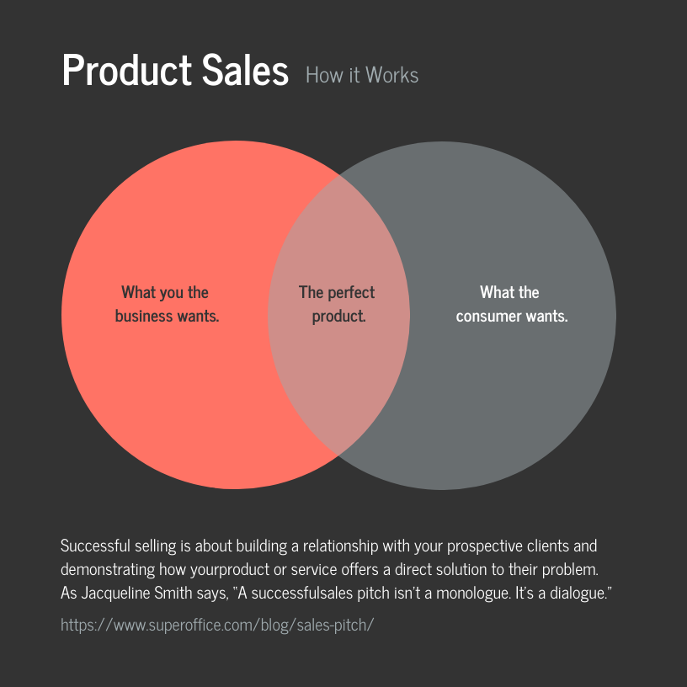

**Fig 1. How Product Sales works**

**1.2.2 The Rise of Advanced Analytics Tools**

The introduction of Google Analytics in 2005 marked a significant milestone in the evolution of web analytics. It revolutionized the way businesses measured and analyzed their online performance. Google Analytics provided a comprehensive set of features, including:

* **Traffic Source Analysis**: Google Analytics allowed businesses to see where their visitors came from, whether it was through search engines, social media, direct visits, or referral links. This feature was instrumental in helping businesses optimize their marketing channels [2][5].
* **Behavior Flow Reports**: Businesses could track how users navigated through their websites, which pages they visited, and at what point they exited. This provided invaluable insights into user experience and website structure [2][3].
* **Conversion Tracking**: One of the most powerful features of modern web analytics tools is the ability to track conversions, which are specific actions users take on a website, such as making a purchase or filling out a form. By tracking conversions, businesses can assess the effectiveness of their website in achieving its goals [6][4].

**1.2.3 Present-Day Tools and Future Trends**

Today, the web analytics landscape is more dynamic than ever. Modern tools incorporate features such as:

* **Real-Time Data Analytics**: Many web analytics platforms now offer real-time data tracking, allowing businesses to see what is happening on their website at any given moment. This is especially useful during major product launches or marketing campaigns when immediate adjustments may be necessary [3][4].
* **Artificial Intelligence and Machine Learning**: Some web analytics tools are beginning to leverage AI and machine learning to provide predictive analytics. These tools can analyze historical data and make predictions about future user behavior, allowing businesses to be proactive in their marketing and user experience strategies [6][5].
* **Multichannel Analytics**: With the rise of digital marketing, businesses no longer rely solely on their websites to reach customers. Social media, mobile apps, and email marketing are just some of the channels businesses use to engage with their audience. Modern web analytics tools provide multichannel tracking capabilities, giving businesses a holistic view of their online presence [4][5].

**1.3 Key Metrics and Concepts in Web Analytics**

A fundamental aspect of web analytics is understanding the various metrics that businesses track to measure success. Some of the most important web analytics metrics include:

* **Page Views and Sessions**: These metrics track the number of times a user views a webpage and the duration of their session, respectively. High page views with short session durations may indicate that users are not finding what they need on the site, leading to quick exits [3][4].
* **Bounce Rate**: The bounce rate measures the percentage of users who leave the website after viewing only one page. A high bounce rate often indicates that the website is not providing engaging or relevant content, leading users to leave without exploring further [1][6].
* **Conversion Rate**: As one of the most critical metrics, the conversion rate measures the percentage of visitors who complete a desired action on the site. This could be making a purchase, signing up for a newsletter, or downloading a white paper. A low conversion rate signals a need for optimization in the user experience or marketing funnel [5][6].
* **Traffic Source Attribution**: Understanding where visitors come from is essential for optimizing marketing efforts. Traffic sources can include organic search, paid ads, social media, email campaigns, and direct visits. By tracking these sources, businesses can allocate their marketing budgets more effectively [2][5].

**1.4 Challenges in Web Analytics**

Despite the benefits, web analytics also presents several challenges:

* **Data Overload**: With so much data available, businesses may struggle to determine which metrics are most important. This can lead to analysis paralysis, where too much data prevents effective decision-making [5][6].
* **Privacy Concerns**: As web analytics tools track user behavior, there is growing concern about data privacy. Businesses must ensure they are compliant with privacy regulations such as the General Data Protection Regulation (GDPR) and the California Consumer Privacy Act (CCPA) [3][4].
* **Integration with Other Tools**: Many businesses use multiple platforms, such as CRM systems, social media analytics, and e-commerce tools. Integrating web analytics with these platforms can be challenging, but it is crucial for gaining a complete view of the customer journey [5][6].

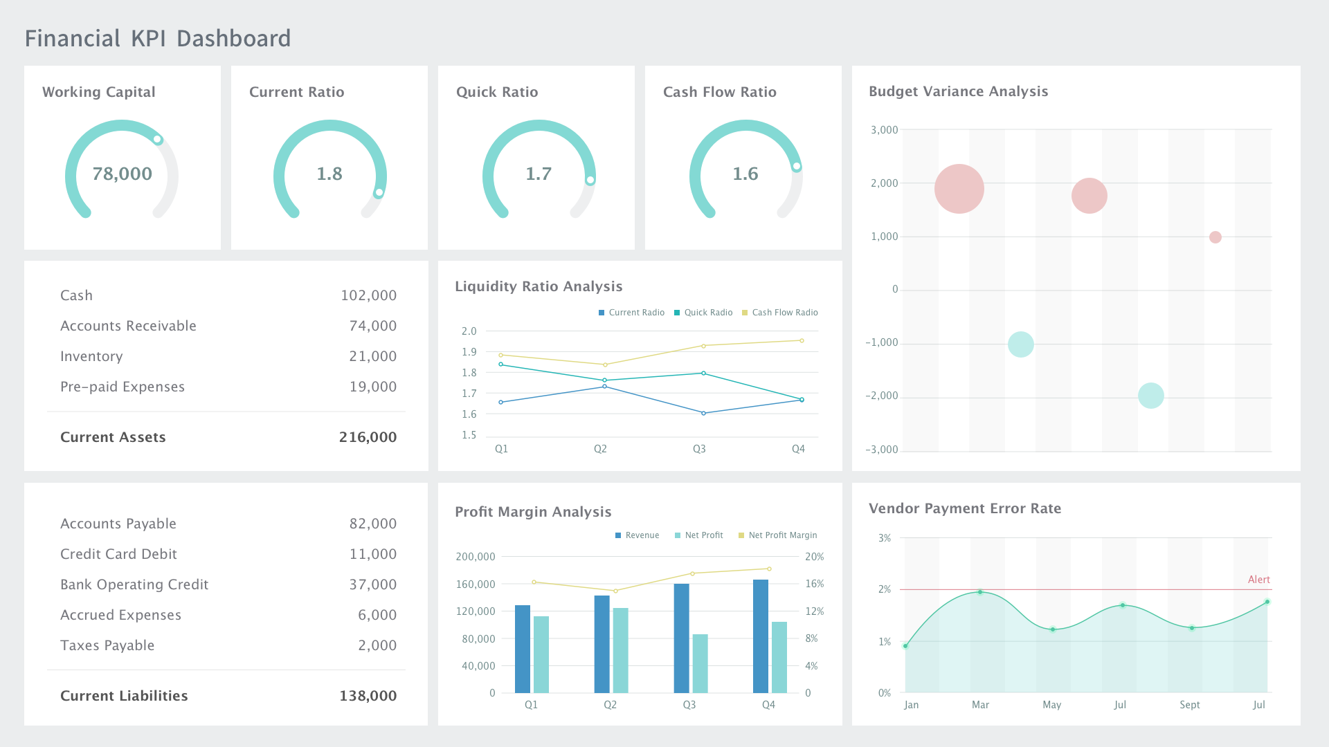

**Fig 2. Financial KPI Dashboard.**

**[Chapter 2: Evolution of Web Analytics](https://markdownlivepreview.com)**

[The evolution of web analytics has profoundly influenced how businesses interact with their online audiences. From rudimentary tools to sophisticated AI-driven platforms, the journey of web analytics reflects technological advancements and changing consumer expectations. Understanding this evolution provides essential context for utilizing these tools effectively today.](https://markdownlivepreview.com)

**[2.1 Early Days of Web Analytics](https://markdownlivepreview.com)**

[In the early days of the internet, webmasters relied primarily on](https://markdownlivepreview.com) **[hit counters](https://markdownlivepreview.com)** [to gauge website traffic. These counters simply recorded the number of times a page was accessed, offering no insights into user behavior, unique visitors, or session duration. This limitation rendered them ineffective for serious businesses seeking to understand their audience. For instance, a hit counter might indicate that a page was visited 1,000 times, but it would not differentiate between 1,000 unique visitors and a single user refreshing the page multiple times [1].](https://markdownlivepreview.com)

[As websites began to evolve and businesses sought to establish a more significant online presence, the limitations of hit counters became increasingly apparent. To address these needs, more sophisticated web analytics tools emerged in the late 1990s, including](https://markdownlivepreview.com) **[WebTrends](https://markdownlivepreview.com)** [and](https://markdownlivepreview.com) **[Omniture](https://markdownlivepreview.com)**[. These tools provided deeper insights, such as tracking the origin of traffic (referral sources) and basic visitor behavior, allowing website owners to understand how users interacted with their sites beyond mere numbers [1]. However, these early analytics solutions were primarily focused on traffic volume rather than user engagement and conversion rates.](https://markdownlivepreview.com)

**[2.2 The Introduction and Impact of Google Analytics](https://markdownlivepreview.com)**

[A transformative moment in the history of web analytics occurred in 2005 when Google launched](https://markdownlivepreview.com) **[Google Analytics](https://markdownlivepreview.com)**[. Prior to its introduction, businesses faced high costs associated with web analytics platforms, often limiting access to larger enterprises with significant budgets. Google Analytics changed this landscape by offering a powerful, free platform, effectively democratizing access to analytics tools for businesses of all sizes [2].](https://markdownlivepreview.com)

[Google Analytics introduced a wealth of features that significantly enhanced how businesses could analyze their web traffic. For instance, it provided metrics such as](https://markdownlivepreview.com) **[bounce rates](https://markdownlivepreview.com)**[—the percentage of visitors who leave a site after viewing only one page—and](https://markdownlivepreview.com) **[conversion tracking](https://markdownlivepreview.com)**[, which allowed businesses to measure the effectiveness of their marketing efforts. These features enabled marketers to establish and track](https://markdownlivepreview.com) **[key performance indicators (KPIs)](https://markdownlivepreview.com)** [tailored to their specific goals, enhancing decision-making and marketing strategies [2].](https://markdownlivepreview.com)

[Moreover, the integration of Google Analytics with other Google services, such as](https://markdownlivepreview.com) **[Google Ads](https://markdownlivepreview.com)**[, allowed businesses to monitor their advertising performance in conjunction with web traffic. This capability provided a comprehensive view of the customer journey, from ad click to site engagement and conversion, thereby informing future advertising strategies and budget allocations [2].](https://markdownlivepreview.com)

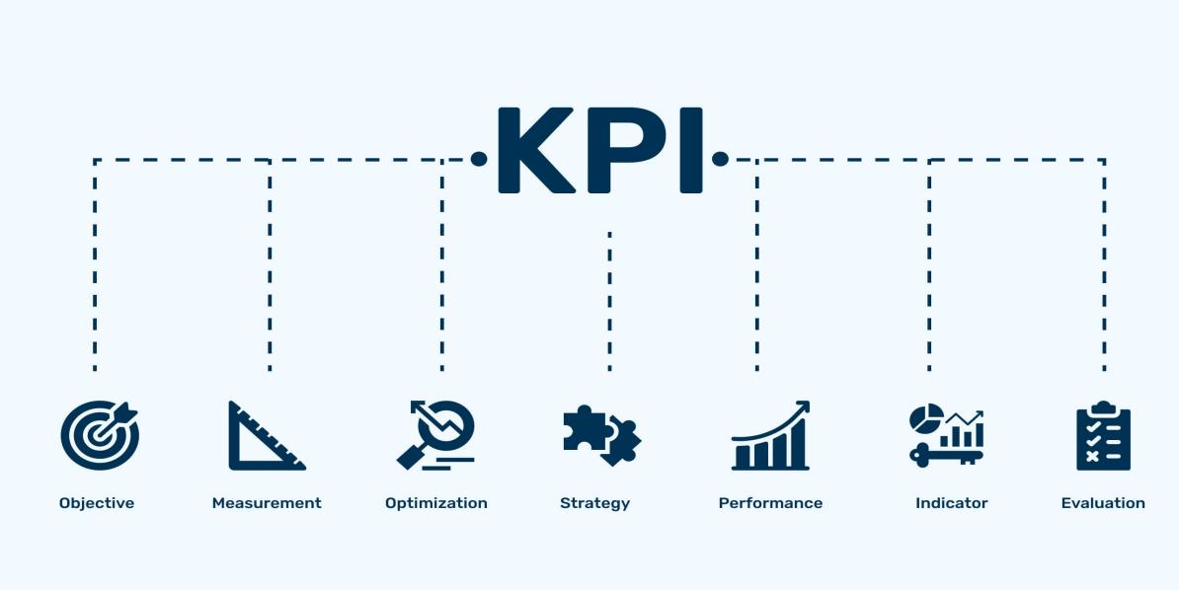

**Fig 3. Key Performance Indicator (KPI’s).**

**[2.3 Event-Based and Behavioral Analytics](https://markdownlivepreview.com)**

[As the web evolved, so did the demand for more granular insights into user behavior. This led to the rise of](https://markdownlivepreview.com) **[event-based analytics](https://markdownlivepreview.com)** [platforms, such as](https://markdownlivepreview.com) **[Mixpanel](https://markdownlivepreview.com)** [and](https://markdownlivepreview.com) **[Heap](https://markdownlivepreview.com)**[. Unlike traditional analytics that primarily focused on page views, event-based analytics tracks specific user actions (events) within a website or application, such as clicks, video plays, or form submissions. This shift allowed businesses to understand not just how many people visited their site, but how they interacted with various elements [5][12].](https://markdownlivepreview.com)

* **[Mixpanel](https://markdownlivepreview.com)** [is a notable example that specializes in tracking user actions and creating complex funnels that reveal how users navigate through a website or app. For example, a retail site could use Mixpanel to track how many users who added items to their cart eventually completed the checkout process. This data helps identify drop-off points in the user journey, enabling targeted improvements to increase conversions [5].](https://markdownlivepreview.com)
* **[Heap](https://markdownlivepreview.com)**[, on the other hand, revolutionized event tracking with its](https://markdownlivepreview.com) **[automatic event tracking](https://markdownlivepreview.com)** [feature. Heap captures all user interactions without requiring developers to manually set up each event, which drastically reduces setup time and improves tracking accuracy. This capability allows businesses to collect comprehensive data on user behavior without the overhead of extensive coding or configuration [12].](https://markdownlivepreview.com)

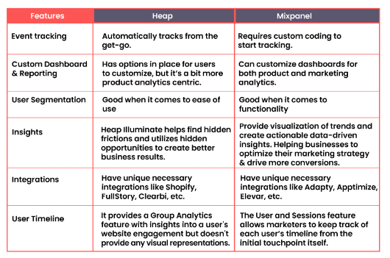

**Table 1: Features of Mixpanel And Heap.**

[These advancements marked a shift toward](https://markdownlivepreview.com) **[behavioral analytics](https://markdownlivepreview.com)**[, emphasizing the understanding of individual user journeys and optimizing for conversion, retention, and engagement.](https://markdownlivepreview.com)

**[2.4 User Experience and Visual Analytics](https://markdownlivepreview.com)**

[As web analytics continued to evolve, a growing emphasis was placed on user experience (UX). Platforms like](https://markdownlivepreview.com) **[Hotjar](https://markdownlivepreview.com)** [and](https://markdownlivepreview.com) **[Crazy Egg](https://markdownlivepreview.com)** [introduced](https://markdownlivepreview.com) **[visual analytics](https://markdownlivepreview.com)** [tools, such as heatmaps and session recordings, which provided businesses with insights into how users interacted with their websites visually [4][10].](https://markdownlivepreview.com)

* **[Heatmaps](https://markdownlivepreview.com)** [are graphical representations that show which areas of a webpage receive the most engagement based on user interactions. For instance, a heatmap might reveal that users predominantly click on a specific call-to-action button while ignoring others. This information helps website owners optimize the layout and design of their pages, enhancing user engagement and navigation [4].](https://markdownlivepreview.com)
* **[Session recordings](https://markdownlivepreview.com)** [allow businesses to watch replays of actual user sessions, giving them the ability to see firsthand how users navigate their sites. This feature is instrumental in identifying usability issues, as businesses can pinpoint where users encounter obstacles or confusion. For example, if users frequently abandon their shopping cart at a particular step in the checkout process, session recordings can reveal potential UX problems, prompting necessary adjustments [10].](https://markdownlivepreview.com)

[These visual analytics tools have empowered businesses to make data-driven decisions that enhance user experience and improve conversion rates, illustrating the value of understanding user interactions on a granular level.](https://markdownlivepreview.com)

**[2.5 Predictive Analytics and Machine Learning](https://markdownlivepreview.com)**

[In recent years, the integration of](https://markdownlivepreview.com) **[artificial intelligence (AI)](https://markdownlivepreview.com)** [and](https://markdownlivepreview.com) **[machine learning (ML)](https://markdownlivepreview.com)** [into web analytics platforms has ushered in a new era of predictive insights. Tools like](https://markdownlivepreview.com) **[Adobe Analytics](https://markdownlivepreview.com)** [and](https://markdownlivepreview.com) **[Matomo](https://markdownlivepreview.com)** [have begun leveraging these technologies to enhance data analysis capabilities, helping businesses anticipate trends and address potential performance issues before they escalate [11][13].](https://markdownlivepreview.com)

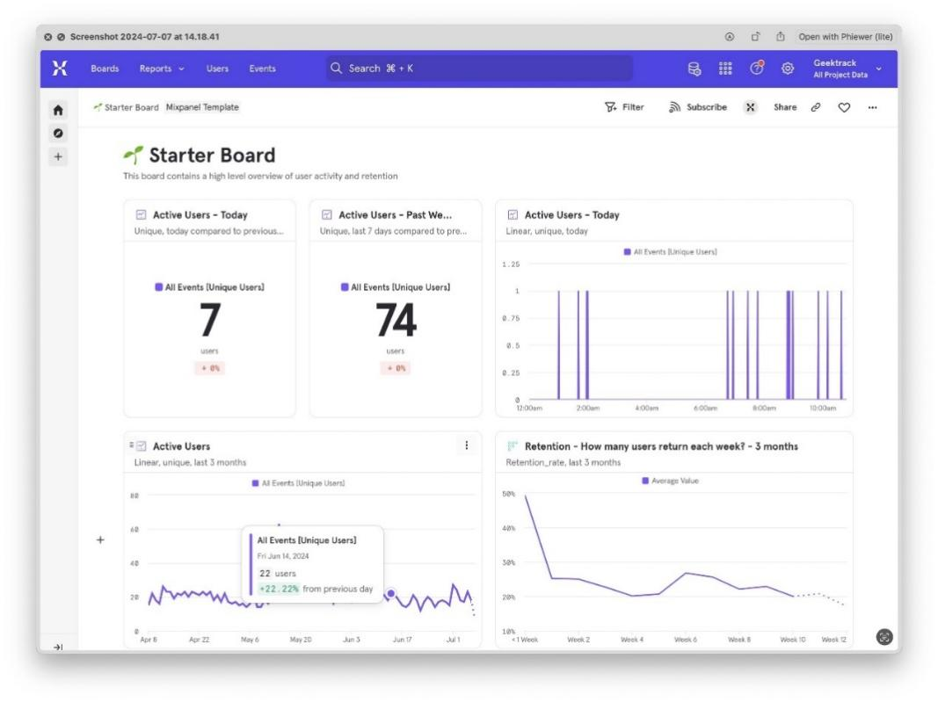

**Fig 4. Telegram bot analytics with Mixpanel.**

* **[Adobe Analytics](https://markdownlivepreview.com)** [incorporates machine learning features to offer predictive insights and anomaly detection, allowing businesses to flag significant trends or issues as they arise. For example, if a sudden drop in traffic is detected, Adobe Analytics can automatically alert users and suggest potential reasons, such as changes in search engine rankings or server issues. This proactive approach enables marketers to react swiftly to potential problems and capitalize on emerging opportunities [11].](https://markdownlivepreview.com)

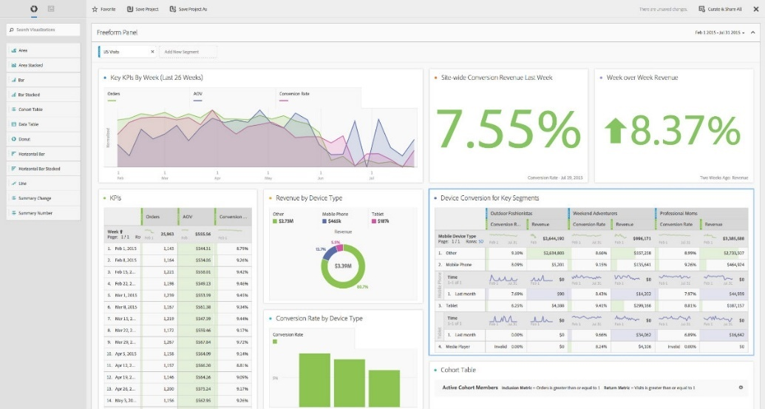

**Fig 5. Adobe analytics unveils data analytic tools.**

* **[Matomo](https://markdownlivepreview.com)** [an open-source analytics platform, employs machine learning to provide insights based on historical user behavior. By analyzing past interactions, Matomo can forecast trends, such as predicting which products are likely to see increased demand during a sale, thus helping businesses make informed decisions about inventory and marketing strategies [13].](https://markdownlivepreview.com)

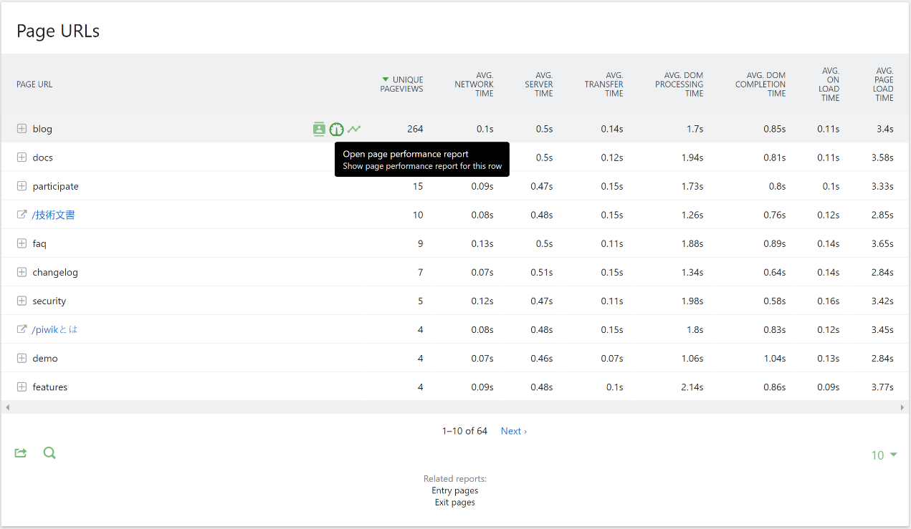

**Fig 6. Matomo analytics showing page perfomance reports.**

[The use of AI and ML in web analytics represents a significant advancement, allowing businesses to move from a reactive data analysis approach to a proactive optimization strategy that maximizes performance and user engagement.](https://markdownlivepreview.com)

**[2.6 Privacy-Focused Analytics](https://markdownlivepreview.com)**

[The increasing focus on data privacy has led to the rise of analytics tools that prioritize user privacy and compliance with regulations such as](https://markdownlivepreview.com) **[GDPR](https://markdownlivepreview.com)** [and](https://markdownlivepreview.com) **[CCPA](https://markdownlivepreview.com)**[. Platforms like](https://markdownlivepreview.com) **[Fathom Analytics](https://markdownlivepreview.com)** [and](https://markdownlivepreview.com) **[Matomo](https://markdownlivepreview.com)** [have become popular choices for businesses seeking to respect user privacy while still gaining valuable insights into their website performance [16][13].](https://markdownlivepreview.com)

* **[Fathom Analytics](https://markdownlivepreview.com)** [adopts a](https://markdownlivepreview.com) **[privacy-first](https://markdownlivepreview.com)** [approach by not collecting personal data or using cookies. This feature makes it an attractive option for businesses that wish to comply with stringent data protection laws while still obtaining meaningful analytics [16].](https://markdownlivepreview.com)
* **[Matomo](https://markdownlivepreview.com)** [stands out as an open-source alternative to traditional analytics tools, offering businesses full control over their data. By allowing users to host their analytics on their own servers, Matomo ensures that data is not shared with third parties. This capability is particularly crucial for industries that handle sensitive information, such as healthcare and finance, where compliance with privacy regulations is paramount [13].](https://markdownlivepreview.com)

[As privacy regulations continue to evolve globally, the demand for analytics platforms that prioritize user privacy and provide data ownership is expected to grow, driving the development of privacy-focused analytics solutions.](https://markdownlivepreview.com)

**Chapter 3: Implementing Web Analytics Tools**

The effective implementation of web analytics tools is a multi-faceted process that directly influences a business's ability to track, analyze, and optimize its online presence. This chapter provides a comprehensive overview of how to select the right analytics tool, set it up correctly, analyze the data effectively, and derive actionable insights to inform strategic decisions.

**3.1 Selecting the Right Analytics Tool**

Choosing the most suitable web analytics tool is crucial for aligning analytics capabilities with the unique objectives of a business. Below are the key factors to consider during the selection process:

1. **Features and Capabilities**:

* **Custom Reporting**: A robust analytics tool should allow for customizable dashboards that can track key performance indicators (KPIs) specific to the business’s objectives. For instance, **Google Analytics** provides users the flexibility to create custom reports focusing on metrics like user engagement, conversion rates, and traffic sources, enabling businesses to tailor their analysis [1].
* **Real-Time Data**: Real-time analytics enable businesses to monitor live user interactions and website performance. Tools like **Hotjar** and **Crazy Egg** provide this feature, allowing businesses to quickly respond to user behavior changes or issues as they arise [4][10]. For example, during a marketing campaign, immediate feedback can help refine strategies on the fly.
* **E-commerce Tracking**: Businesses that rely on online sales should prioritize tools that offer comprehensive e-commerce tracking features. These include detailed reporting on sales performance, cart abandonment rates, and revenue metrics. **Adobe Analytics** is particularly well-regarded for its in-depth e-commerce insights, which help businesses optimize their online stores [11].
* **Segmentation and Audience Insights**: Advanced segmentation capabilities allow businesses to analyze user behavior based on different criteria, such as demographics, interests, and behavior patterns. This helps in understanding how various user segments interact with the website, enabling targeted marketing strategies. For example, using segmentation to analyze first-time ersus returning visitors can reveal valuable insights about user retention [5].

1. **Scalability**:

* **Data Volume Management**: As businesses grow, the volume of data generated will increase significantly. It is crucial to select analytics tools that can handle large amounts of data without performance degradation. **Mixpanel** is an example of a tool that scales effectively, making it suitable for businesses anticipating rapid growth [6].
* **Future-Proofing**: The ability to adapt to changing business needs is essential when selecting an analytics tool. Some platforms, like **Heap**, offer automatic tracking of user interactions, which allows businesses to be agile and responsive as their analytics requirements evolve [12].

1. **User Experience**:
   * **Interface and Usability**: A tool with a user-friendly interface can significantly reduce the learning curve and make data analysis accessible to non-technical users. **GoSquared** emphasizes intuitive design, enabling users to navigate data insights easily and effectively [3]. This ease of use can improve adoption rates across teams within the organization.
   * **Support and Community**: It is important to assess the level of customer support and the strength of the user community surrounding a tool. Robust documentation, tutorials, and active user forums can facilitate problem resolution and provide valuable tips and best practices for effective tool usage [11].
2. **Cost Considerations**:
   * **Budgeting**: There is a wide range of pricing models for analytics tools, from free options like **Google Analytics** to premium services like **Adobe Analytics**. Businesses must weigh the cost against the features provided to ensure they achieve a good return on investment [2].
   * **Trial Periods**: Taking advantage of free trials or freemium models is a strategic approach to evaluate different tools. Businesses can test functionalities and suitability before committing to a long-term subscription, ensuring that the chosen tool aligns with their specific needs [1].

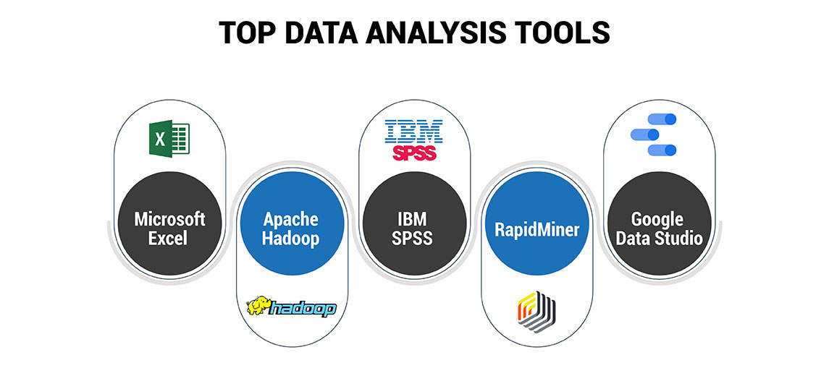

**Fig 7. Analytical Tools.**

**3.2 Setting Up the Analytics Tool**

After selecting the right analytics tool, the next step is to set it up correctly to ensure effective data collection. The setup process typically involves the following components:

1. **Account Creation**:
   * The first step involves registering for an account with the chosen analytics provider, which usually requires basic information about the website or application being tracked. Verification of ownership is often necessary, achieved through methods such as adding a meta tag or uploading a specific file to the server [2].
2. **Tag Implementation**:
   * **Adding Tracking Codes**: Most analytics platforms require users to insert tracking codes into their website. These JavaScript snippets enable data collection on user interactions. Proper placement of the tracking code, typically in the header of every page, ensures comprehensive data capture. **Google Tag Manager** simplifies this process by allowing the management of multiple tracking codes from a single interface, reducing complexity and risk of errors [4].
   * **Data Layer Configuration**: For advanced tracking needs, configuring a data layer can help capture additional user interactions, providing richer and more detailed data for analysis. A data layer acts as a centralized repository for storing data that can be accessed by various marketing and analytics tools [1].
3. **Goal Configuration**:
   * Setting specific goals within the analytics tool is critical for tracking conversions effectively. Goals might include actions such as completing a purchase, filling out a contact form, or subscribing to a newsletter. Clearly defined goals allow businesses to measure success and optimize strategies accordingly [2][5].
   * For instance, if a business sets up a goal to track newsletter sign-ups, it can analyze how users interact with its site to optimize the newsletter’s visibility and increase sign-up rates.
4. **Test and Validate**:
   * Testing the implementation is essential to ensure data accuracy. Using features such as real-time reporting helps verify that tracking codes are functioning as intended. Additionally, conducting user tests can confirm that goals are triggered correctly when users complete the desired actions on the site [1].

**3.3 Analyzing the Data**

With data collection in place, businesses must focus on effectively analyzing the information gathered. This analysis is essential for understanding user behavior and deriving actionable insights:

1. **Traffic Sources**:
   * Analyzing traffic sources helps businesses understand how users find their site, whether through organic search, paid ads, social media, or referrals. Identifying high-performing channels allows businesses to allocate resources more effectively and optimize marketing strategies. For instance, if a significant amount of traffic is generated from social media, businesses may decide to invest more in those advertising channels [1].
   * Understanding traffic sources can also guide content strategy; for example, if users are finding the site via blog posts, businesses might focus on creating more content in that area [6].
2. **User Behavior**:
   * Metrics related to user behavior, such as bounce rate, session duration, and pages per session, provide insights into how visitors interact with the site. A high bounce rate may indicate that visitors are not finding what they expect, prompting a review of the content and design. This analysis helps identify areas for improvement [11].
   * Tools like **Crazy Egg** can enhance understanding of user behavior by providing heatmaps that visualize where users click and scroll, allowing businesses to optimize page layouts for better engagement [5].
3. **Conversion Rates**:
   * Monitoring conversion rates reveals the percentage of users who complete desired actions, providing insight into the effectiveness of marketing campaigns and website changes. By analyzing conversion data, businesses can identify successful strategies and pinpoint areas needing improvement [12].
   * For example, if a landing page has a low conversion rate, businesses may choose to redesign it or change the call-to-action to enhance user engagement and drive conversions [4].
4. **Segmentation**:
   * Segmentation enables businesses to categorize users based on specific criteria, such as demographics, behavior, or acquisition channels. This targeted approach offers deeper insights into user preferences and can inform personalized marketing strategies. For instance, analyzing segmented data allows businesses to tailor their content and marketing messages to resonate more effectively with different audience groups [1].
   * By understanding the behaviors of different segments, businesses can craft personalized experiences that drive higher engagement and conversion rates [11].

**3.4 Deriving Actionable Insights**

The ultimate goal of web analytics is to convert raw data into actionable insights that inform business strategies. Below are several methods to achieve this:

1. **A/B Testing**:
   * A/B testing, or split testing, involves comparing two versions of a webpage to determine which performs better based on user interactions and conversion rates. By analyzing data from both versions, businesses can identify the most effective design and content elements. This iterative process enables continuous optimization of user experience, ultimately leading to improved conversion rates over time [4].
   * For example, a business might test two different headlines for a landing page to see which results in higher sign-up rates [6].



**Fig 8. A/B Testing**

1. **Personalization**:
   * Leveraging data for personalization can significantly enhance user experience and engagement. For instance, e-commerce sites can utilize past purchase data to recommend products tailored to individual user preferences, increasing the likelihood of repeat purchases [11].
   * Personalization strategies can also extend to email marketing, where targeted campaigns based on user behavior can lead to higher open and click-through rates [12]. This approach ensures that users receive relevant content, improving overall engagement.

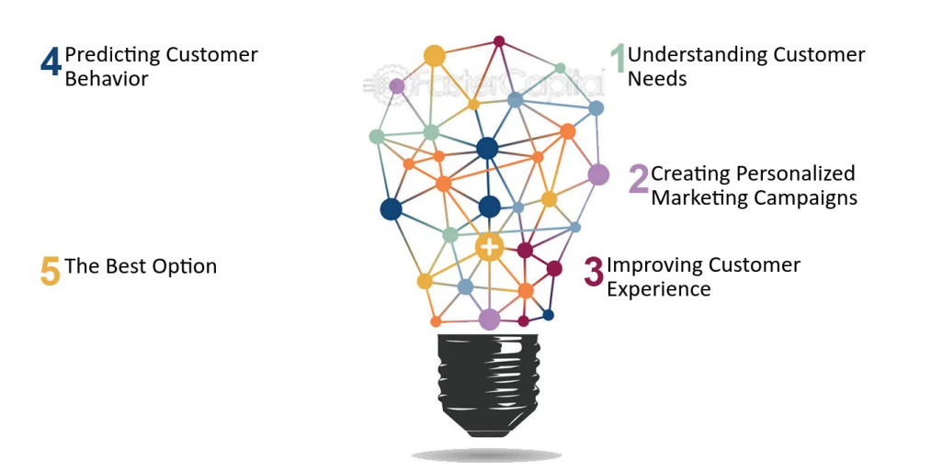

**Fig 9. Importance of Personalization in Data Analytics.**

1. **Continuous Improvement**:
   * Web analytics is an ongoing process that necessitates regular review and adjustment. Businesses should routinely analyze their data, measure performance against established goals, and adapt their strategies as needed. This commitment to continuous improvement fosters a culture of data-driven decision-making, ensuring that marketing efforts remain effective in a rapidly changing digital landscape [1].
   * Businesses can leverage insights gained from analytics to refine their marketing strategies, improve customer experiences, and ultimately drive revenue growth [10].
2. **Collaborative Decision-Making**:
   * Involving multiple departments in the analysis process can enhance the quality of insights generated. Engaging teams from marketing, sales, and product development allows for a holistic view of user behavior and its

impact on various aspects of the business. This collaborative approach ensures that decisions are informed by diverse perspectives and expertise [12].

* Regular cross-departmental meetings to review analytics findings can facilitate strategic alignment and ensure that all teams are working toward shared goals [4].

**Chapter 4: Implementing Web Analytics Tools**

In this chapter, we will discuss the practical aspects of implementing web analytics tools, focusing on the steps required to set them up and integrate them into your digital strategy. We will also delve into best practices for utilizing these tools effectively to maximize their benefits for your business.

**4.1 Setting Up Web Analytics Tools**

The initial step in implementing web analytics tools is selecting the appropriate tool that aligns with your business goals. Various tools are available, each offering distinct features and capabilities. Some of the most popular options include Google Analytics, Adobe Analytics, Matomo, and Clicky. After selecting a tool, the next steps include:

* **Creating an Account**: Sign up for the chosen web analytics platform. This process typically involves providing your email address, company information, and other relevant details. Some tools offer free trials, allowing you to explore their features before committing to a subscription. Be sure to verify your account through the confirmation email sent by the service.
* **Adding Tracking Code**: Most web analytics tools require you to insert a tracking code into your website's HTML. This code collects data on user interactions, page views, and other metrics. For example, Google Analytics generates a specific tracking code that must be placed in the header of your web pages. Ensuring this code is correctly implemented across all pages is crucial for comprehensive data collection. You can utilize Google Tag Manager to manage and deploy various tracking codes efficiently without modifying your website's code each time.
* **Setting Up Goals and Events**: After integrating the tracking code, set up specific goals within your analytics tool. Goals can include actions like completing a purchase, signing up for a newsletter, or spending a certain amount of time on the site. Additionally, configuring events allows you to track specific user interactions, such as button clicks or video views, providing deeper insights into user engagement. For instance, in Google Analytics, you can set up "Smart Goals" that use machine learning to identify valuable users based on engagement metrics, helping you optimize your targeting efforts [3].
* **Configuring User Permissions**: If your organization has multiple team members accessing the analytics tool, it's important to configure user permissions. This ensures that team members have appropriate access levels, enhancing security and data integrity. Different users can be granted varying levels of access based on their roles, allowing for effective collaboration while safeguarding sensitive data. For instance, administrators can manage user settings while analysts can access data views without altering the configurations [1].

**4.2 Integrating Web Analytics with Your Digital Strategy**

After setting up the tracking code, it’s essential to integrate web analytics into your overall digital strategy. This integration ensures that the data collected is effectively utilized to inform marketing decisions and website improvements. Key integration steps include:

* **Defining Goals and KPIs**: Identify the specific goals you want to achieve through your website, such as increasing conversion rates, enhancing user engagement, or improving customer retention. Establishing Key Performance Indicators (KPIs) helps track the success of these goals. For instance, if your goal is to increase sales, a relevant KPI might be the conversion rate or average order value. Additionally, consider using benchmarks to compare your performance against industry standards, helping you set realistic targets [6].
* **Utilizing Conversion Tracking**: Many web analytics tools offer conversion tracking features. This allows businesses to monitor user actions that lead to desired outcomes, such as filling out a contact form or making a purchase. Setting up conversion tracking enables you to assess the effectiveness of marketing campaigns and optimize strategies accordingly. You can analyze which traffic sources are driving conversions and adjust your marketing efforts to focus on the most successful channels. Implementing UTM parameters in your URLs can also enhance tracking by providing detailed information on the source and medium of traffic [2].
* **Integrating with Other Marketing Tools**: To enhance the power of web analytics, consider integrating them with other marketing tools, such as Customer Relationship Management (CRM) systems, email marketing platforms, and social media management tools. This integration allows for a more comprehensive view of user interactions across different channels, enabling better-targeted marketing strategies and personalized user experiences. For example, integrating Google Analytics with a CRM can provide insights into customer behavior, leading to more effective lead nurturing and retention strategies [5].

**4.3 Best Practices for Using Web Analytics Tools**

To ensure the successful implementation and utilization of web analytics tools, consider the following best practices:

* **Regular Data Review**: Regularly review the data collected by your analytics tool to identify trends and insights. Monthly or weekly reviews can help you stay updated on user behavior and website performance. Look for significant changes in metrics such as bounce rates, traffic sources, and conversion rates to determine areas for improvement. Additionally, setting up automated reports can streamline this process, allowing for easy tracking of KPIs over time [4].
* **Segmentation**: Utilize segmentation features to analyze different groups of users based on behavior, demographics, or traffic sources. This analysis helps tailor marketing strategies to specific audiences, enhancing engagement and conversion rates. For example, you might segment users based on whether they are new or returning visitors, allowing you to craft targeted messages that resonate with each group. This segmentation can be applied to email marketing campaigns to deliver personalized content that improves click-through rates [2].
* **A/B Testing**: Conduct A/B testing to compare different versions of web pages or marketing campaigns. This practice allows you to determine which variations perform better, enabling data-driven decisions to improve user experience. Testing elements such as headlines, call-to-action buttons, and layouts can lead to higher engagement and conversion rates. Document your findings to create a repository of effective strategies. Tools like Google Optimize can facilitate A/B testing by allowing you to create experiments easily and analyze results effectively [7].
* **Custom Dashboards**: Create custom dashboards within your analytics tool to visualize key metrics at a glance. This practice enables you to quickly monitor performance and share insights with team members or stakeholders. Custom dashboards can highlight important KPIs, making it easier to track progress toward business goals. For example, in Google Analytics, you can use the "Customization" tab to create tailored reports that focus on metrics most relevant to your business objectives [6].
* **Education and Training**: Invest in ongoing education and training for your team to ensure they are well-versed in utilizing the analytics tools effectively. This training could involve workshops, webinars, or online courses focusing on data analysis, interpretation, and practical applications of analytics in decision-making. Encouraging team members to pursue certifications (e.g., Google Analytics Individual Qualification) can also enhance their skills and confidence in using analytics tools [8].

**4.4 Challenges in Implementing Web Analytics Tools**

While implementing web analytics tools can provide valuable insights, several challenges may arise:

* **Data Privacy Concerns**: With increasing regulations around data privacy, businesses must ensure compliance with laws such as GDPR and CCPA. It’s crucial to implement proper consent mechanisms and anonymize user data when necessary. Businesses should also consider the implications of using third-party cookies and strive to maintain transparency with users regarding data collection practices. Providing clear privacy policies can help establish trust and reassure users about how their data is being utilized [1].
* **Complexity of Tools**: Some web analytics tools can be complex, requiring significant training for users. Providing adequate training and resources for team members is vital to maximizing the potential of these tools. Ensure that team members feel comfortable navigating the platform and understanding the data presented. Additionally, consider creating internal documentation or knowledge bases to support team members in using the analytics tools effectively [5].
* **Overcoming Data Overload**: With the wealth of data collected through web analytics, it can be easy to become overwhelmed. Focus on the most relevant metrics and avoid the temptation to chase every piece of data. Establish clear goals and align your analytics strategy with those objectives to prevent analysis paralysis. Regularly revisit your goals and adjust the metrics you track to ensure they remain aligned with your business objectives [8].
* **Budget Constraints**: Depending on the scale of your business, budget constraints may limit your ability to utilize premium analytics tools or hire dedicated data analysts. To mitigate this, prioritize tools that offer a free tier or trial period, allowing you to assess their value before making financial commitments. Furthermore, consider leveraging open-source analytics tools like Matomo, which can provide robust features without the high costs associated with premium solutions [4].

In summary, implementing web analytics tools is a critical step for businesses looking to leverage data to enhance their online performance. By carefully selecting tools, integrating them with digital strategies, and adhering to best practices, businesses can effectively utilize analytics to drive growth and improve user experiences. Each step in this process contributes to a comprehensive understanding of user behavior and website performance, allowing businesses to make informed decisions.

The following chapter will delve into data interpretation and how to derive actionable insights from the analytics gathered.

**Chapter 5: Future Trends in Web Analytics**

The web analytics landscape is rapidly evolving due to technological advancements, shifting consumer behaviors, and increasing regulatory pressures. Businesses must stay ahead of these trends to harness the full potential of their data. This chapter delves into several key trends shaping the future of web analytics, including the integration of artificial intelligence (AI) and machine learning (ML), a heightened focus on data privacy and security, the rise of real-time analytics, the importance of cross-channel data integration, and the emerging trends in data visualization, customer journey mapping, and the use of data storytelling.

**5.1 Artificial Intelligence and Machine Learning**

Artificial intelligence and machine learning are revolutionizing web analytics by enhancing data processing capabilities and providing deeper insights into user behavior. These technologies facilitate predictive analysis, automated insights, and natural language processing.

* **Predictive Analytics**: By utilizing historical data, AI algorithms can predict future user behaviors and trends, empowering businesses to anticipate customer needs. For instance, e-commerce companies can employ predictive analytics to recommend products based on users' previous interactions, thus enhancing the shopping experience and increasing conversion rates [9][13]. For example, Amazon uses predictive analytics to suggest products, which contributes significantly to its sales [7].

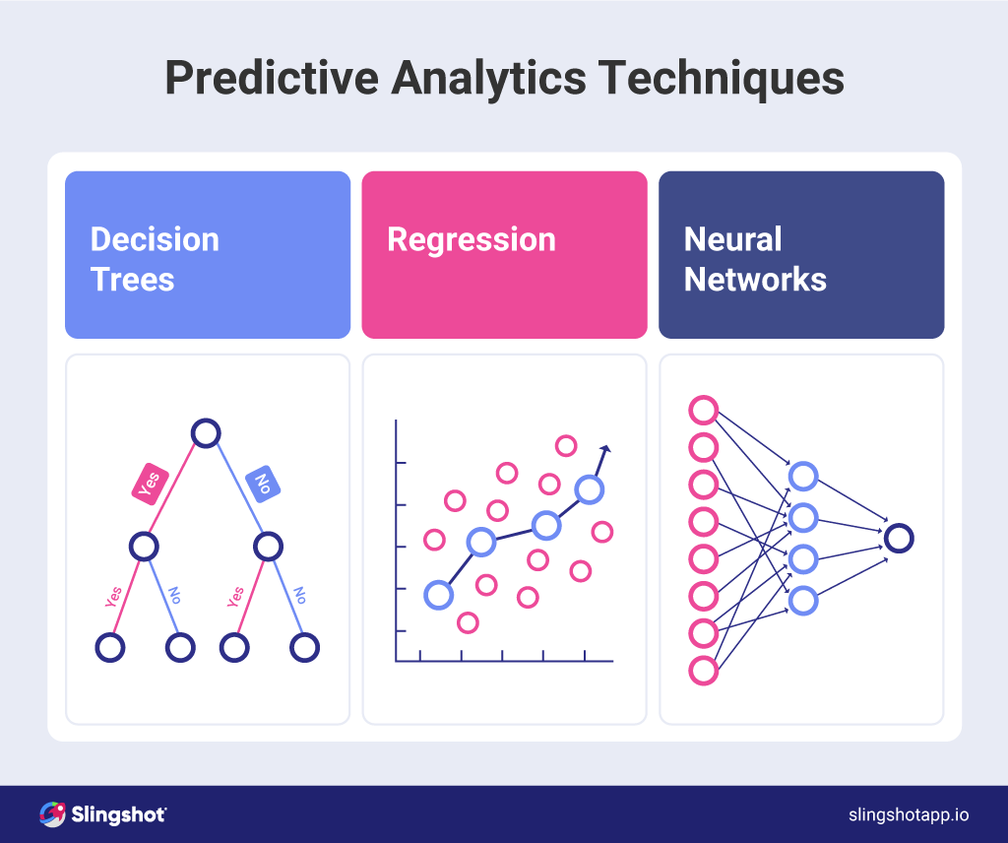

**Fig 10. Predictive Analytics Techniques.**

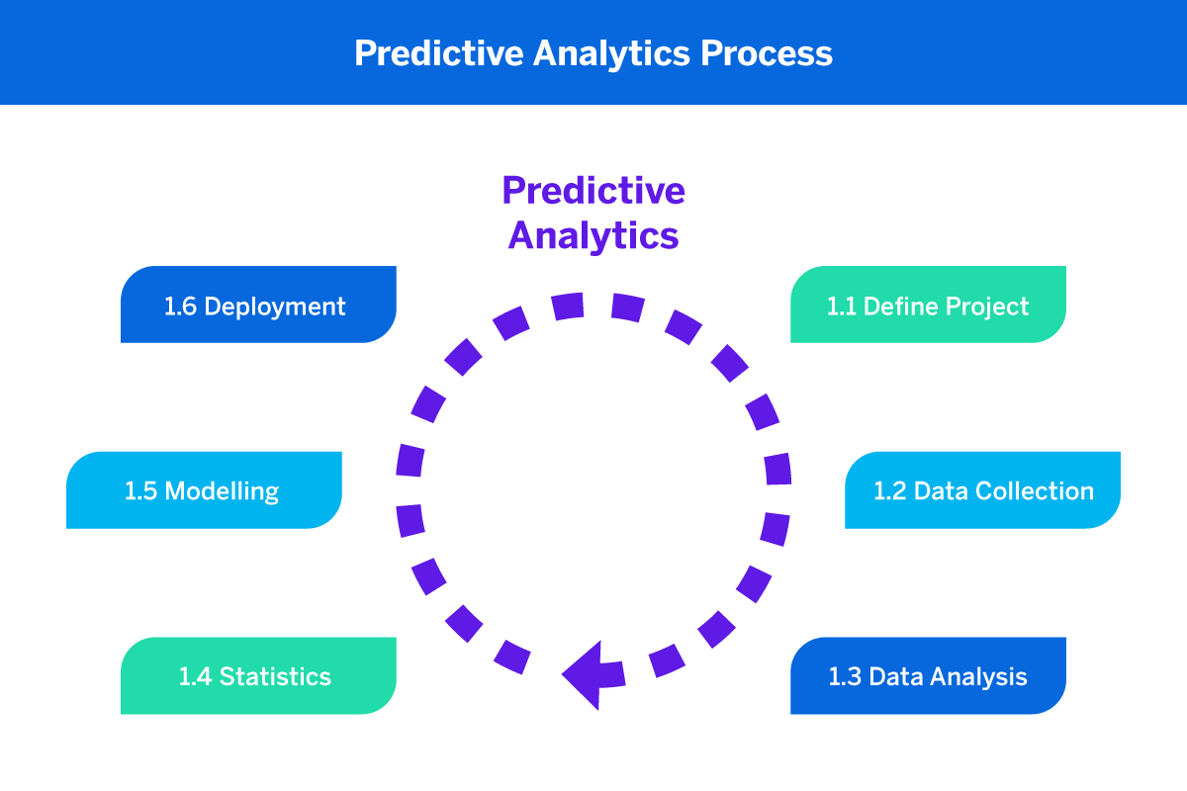

**Fig 11. Predictive Analytics Process.**

* **Automated Insights**: Machine learning algorithms can automate data analysis processes, allowing companies to generate insights quickly and efficiently. These automated insights can identify key trends in user behavior, such as identifying which marketing campaigns yield the highest engagement, thus informing strategic decisions [5][11]. For example, Google Analytics’ Intelligence feature automatically identifies significant changes in data and sends alerts to users, helping them act swiftly on emerging trends [12][14].
* **Natural Language Processing (NLP)**: NLP technology allows web analytics tools to analyze unstructured data from sources such as social media and customer feedback. By processing this information, businesses can better understand customer sentiment and preferences [11]. For example, tools like MonkeyLearn can extract insights from customer reviews, enabling brands to address pain points in their products or services [10][14].

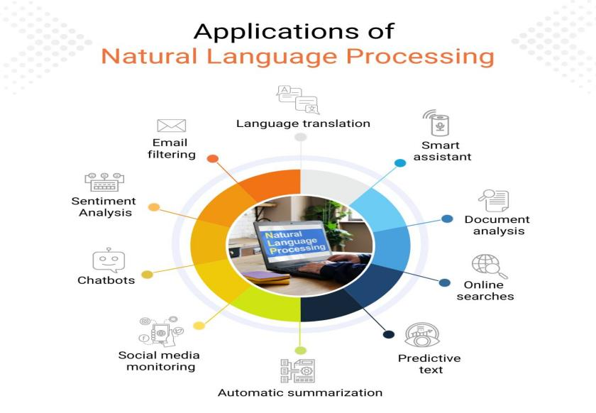

**Fig 12. Applications of Natural Language Processing**

* **Enhanced User Segmentation**: AI and ML can also improve user segmentation by identifying patterns and clusters within user data. This enables businesses to create more targeted marketing strategies and personalized user experiences. For instance, using clustering algorithms, companies can group customers based on their buying habits, allowing for tailored promotions [7][12].

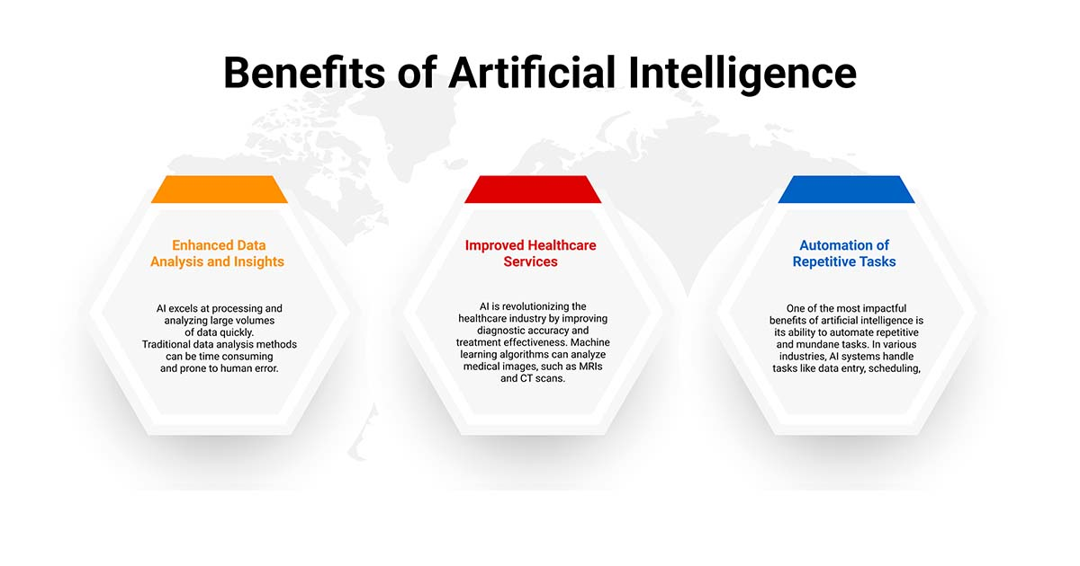

**Fig 13. Benefits Of Artificial Intelligence.**

**5.2 Increased Focus on Privacy and Data Security**

As awareness of data privacy grows, businesses must prioritize data security and comply with stringent regulations. This trend emphasizes the need for transparency in data practices and the ethical use of consumer data.

* **Compliance with Regulations**: The introduction of regulations such as the General Data Protection Regulation (GDPR) and the California Consumer Privacy Act (CCPA) has forced businesses to rethink their data collection practices. Compliance with these regulations requires companies to be transparent about how they collect, store, and use consumer data [12][14]. Analytics platforms are adapting by incorporating features that allow users to manage their privacy preferences, ensuring compliance and fostering trust [9][11].
* **First-Party Data Utilization**: With the decline of third-party cookies, businesses are shifting their focus to first-party data—information gathered directly from user interactions. First-party data is considered more reliable as it is collected with user consent [12][13]. Companies can enhance their analytics capabilities by utilizing CRM systems that facilitate first-party data collection. For instance, brands can leverage loyalty programs to gather valuable customer insights while respecting user privacy [9][14].
* **Privacy-Centric Analytics Tools**: There is a growing demand for analytics tools that prioritize user privacy. Platforms like Matomo and Fathom offer analytics solutions that comply with privacy regulations while providing meaningful insights. These tools often anonymize user data and emphasize aggregate metrics to respect individual privacy [11][12]. Such privacy-centric approaches help companies build consumer trust and ensure compliance [9][10].
* **Data Minimization Practices**: Companies are increasingly adopting data minimization strategies, collecting only the data necessary for their operations. This practice not only enhances privacy but also reduces the risk associated with data breaches. By minimizing the data collected, businesses can better safeguard sensitive information [12][13].

**5.3 Real-Time Analytics**

Real-time analytics is becoming a critical component of web analytics as businesses seek immediate insights to make data-driven decisions. This trend enables organizations to respond swiftly to changes in user behavior and market dynamics.

* **Instant Feedback Loops**: Real-time analytics tools allow businesses to monitor user interactions as they happen, providing immediate feedback on website performance and marketing effectiveness [10][14]. This capability enables companies to adjust strategies on the fly. For example, if an online retailer notices a surge in traffic to a specific product page, they can quickly promote that product through targeted marketing efforts, enhancing conversion opportunities [5][11].
* **Proactive Problem Solving**: With real-time data, businesses can swiftly identify and address issues such as website glitches or declining engagement on particular pages. For instance, if a website experiences a sudden drop in traffic, real-time analytics can help identify whether the issue stems from technical problems or ineffective marketing strategies [4][10]. This proactive approach minimizes potential losses and improves overall user experience.
* **Enhanced Customer Support**: Real-time analytics can significantly enhance customer support by allowing businesses to monitor user behavior and identify customers who may need assistance. For instance, live chat features can be deployed to engage users showing signs of frustration, such as spending too long on a checkout page [12][14]. This level of responsiveness improves customer satisfaction and fosters loyalty [5].
* **Dynamic Pricing Models**: Real-time analytics enables businesses to implement dynamic pricing strategies based on current market demand, competitor pricing, and customer behavior. This agility in pricing can optimize revenue and enhance competitiveness [7][10].

**5.4 Integration of Cross-Channel Data**

As consumer interactions increasingly span multiple platforms, the integration of cross-channel data becomes vital for comprehensive insights into user behavior and marketing effectiveness.

* **Omni-Channel Marketing Strategies**: Companies are realizing the importance of adopting omni-channel marketing strategies that deliver consistent messaging across all platforms [11][13]. By integrating data from web analytics, social media, email marketing, and in-store interactions, businesses can gain a holistic view of customer journeys. For example, a retailer might analyze data from their website, social media engagement, and in-store purchases to develop a unified marketing strategy that resonates with customers at every touchpoint [9][12].
* **Attribution Modeling**: Accurate attribution modeling is crucial for understanding the impact of various marketing channels on conversions. By integrating cross-channel data, businesses can track user interactions across different platforms and develop sophisticated attribution models that recognize the contributions of multiple channels [7][11]. For instance, a company might use multi-touch attribution to credit a series of interactions—social media ads, email newsletters, and website visits—with driving a sale, allowing them to optimize their marketing spend effectively [12][13].
* **Data Visualization**: Advanced data visualization tools are emerging to help businesses interpret integrated data from multiple sources. These tools enable stakeholders to easily understand complex data relationships and trends, facilitating better decision-making [14][10]. For instance, platforms like Tableau and Google Data Studio allow users to create visual dashboards that integrate data from various marketing channels, providing a comprehensive overview of performance [11][12].
* **Customer Journey Mapping**: Integration of cross-channel data aids in creating detailed customer journey maps that illustrate how users interact with a brand across various touchpoints. This understanding helps businesses refine their strategies and enhance customer experiences [12][13].

**5.5 Emerging Trends in Data Visualization**

As the volume of data grows, effective data visualization becomes essential for interpreting insights quickly and accurately. Emerging trends in data visualization include:

* **Interactive Dashboards**: Businesses are increasingly adopting interactive dashboards that allow users to explore data dynamically, enabling them to focus on the metrics that matter most to their objectives. This interactivity fosters a deeper understanding of performance and aids in strategic decision-making [11][12].

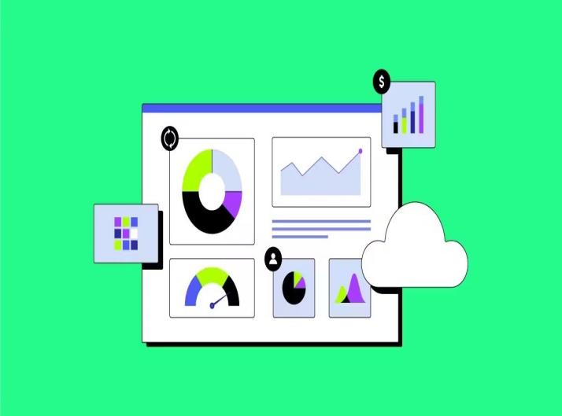

**Fig 14. Interactive Dashboard.**

* **Augmented Reality (AR) and Virtual Reality (VR)**: The integration of AR and VR into data visualization tools is on the rise, offering immersive ways to present data. These technologies can help stakeholders visualize complex data sets in more engaging and understandable formats [10][14].



**Fig 15. Augmented Reality(AR) and Virtual Reality(VR).**

* **Storytelling with Data**: Data storytelling combines data visualization with narrative techniques to present insights compellingly and understandably. This approach helps convey the significance of data findings to diverse audiences, making analytics more accessible to decision-makers across organizations [12][13].

  
**Fig 16. Storytelling with data.**

**Chapter 6: Practical Applications of Web Analytics**

Web analytics is essential for businesses seeking to optimize their online presence and improve overall performance. This chapter explores the practical applications of web analytics, detailing how businesses can implement effective analytics strategies, identify key performance indicators (KPIs), and learn from case studies of successful implementations.

**6.1 Implementing a Web Analytics Strategy**

Implementing a successful web analytics strategy requires careful planning and execution. Here are key steps businesses can follow:

1. **Define Clear Objectives**: Establish specific goals for what the business hopes to achieve with web analytics. Objectives may include:
   * Increasing website traffic by a certain percentage within a defined time frame.
   * Improving conversion rates from site visitors to customers.
   * Enhancing user engagement through better content and navigation.
   * Boosting sales through targeted marketing efforts.

For instance, an e-commerce site may aim to increase its conversion rate by 20% over the next year through various initiatives, including optimizing the user journey and implementing targeted marketing campaigns[14].

1. **Choose the Right Tools**: Select appropriate web analytics tools that align with the business’s goals and budget. Popular tools include:
   * **Google Analytics**: Ideal for general web tracking and providing insights into user behavior.
   * **Hotjar**: Useful for heatmaps and user recordings, helping understand how users interact with the site.
   * **Adobe Analytics**: Offers advanced analytics features for larger enterprises looking for deeper insights.
   * **Mixpanel**: Focused on event-based tracking, helping understand user interactions and product usage.

Each tool offers unique features that can cater to different needs, so businesses should evaluate their specific requirements before choosing a tool[12][14].

1. **Set Up Tracking**: Implement tracking codes on the website to collect data effectively. This process involves:
   * Adding JavaScript snippets to web pages, which can be managed through tag management systems like Google Tag Manager.
   * Setting up goals and conversion tracking within the analytics tool to measure success accurately.
   * Ensuring accurate setup is critical for data reliability, which may involve working with developers or webmasters to validate implementations[12][14].
2. **Segment Data**: Utilize segmentation to break down data into meaningful groups. This can include:
   * **Demographic Segmentation**: Age, gender, location, and interests of visitors.
   * **Behavioral Segmentation**: User behavior such as pages visited, time spent on site, and previous interactions.
   * **Traffic Source Segmentation**: Understanding where visitors are coming from (e.g., organic search, social media, paid ads).

This segmentation allows for more precise analysis, enabling businesses to tailor their marketing efforts and improve user experiences[10][14].

1. **Regularly Review and Optimize**: Establish a routine for reviewing analytics data and optimizing strategies. This includes:
   * Conducting weekly or monthly reviews to identify trends, patterns, and areas for improvement.
   * Utilizing A/B testing to determine the effectiveness of different strategies, such as marketing campaigns or website designs.
   * Adjustments can be made based on the insights gathered, allowing businesses to stay responsive to user needs[14][12].
2. **Train Staff**: Ensure that team members are trained in using analytics tools and understanding data insights. This training should focus on:
   * Interpreting data effectively and applying insights to business strategies.
   * Encouraging a data-driven culture within the organization to empower employees at all levels.
   * Offering continuous learning opportunities as analytics tools and techniques evolve[12][10].
3. **Leverage Data Visualization Tools**: Use data visualization tools to present analytics insights clearly and concisely. Tools like Tableau or Google Data Studio can help:
   * Create interactive dashboards that allow stakeholders to explore data intuitively.
   * Transform complex data into understandable visuals that facilitate decision-making processes[14][12].

**6.2 Key Performance Indicators (KPIs)**

Selecting the right KPIs is essential for measuring the success of web analytics initiatives. KPIs should align with the defined objectives and provide actionable insights. Common KPIs include:

* **Traffic Metrics**:
  + **Sessions**: Total visits to the site, indicating overall engagement levels.
  + **Unique Visitors**: Count of individual users visiting the site over a specific period, reflecting reach.
* **Engagement Metrics**:
  + **Bounce Rate**: Percentage of visitors who leave the site after viewing only one page, reflecting content relevance and user experience.
  + **Average Session Duration**: Time spent on the site, indicating user engagement and interest.
  + **Pages per Session**: Average number of pages viewed during a session, providing insights into user navigation patterns.
* **Conversion Metrics**:
  + **Conversion Rate**: Percentage of visitors completing a desired action (e.g., purchases, sign-ups), serving as a direct measure of marketing effectiveness[14][10].
  + **Cart Abandonment Rate**: Percentage of users who add items to their cart but leave without completing the purchase, highlighting areas for improvement in the checkout process[12][14].
  + **Lead Generation**: Number of leads generated through contact forms, newsletters, or downloads, essential for B2B businesses.
* **Revenue Metrics**:
  + **Revenue per Visitor (RPV)**: Average revenue generated per visitor, helping assess overall site profitability[10].
  + **Customer Lifetime Value (CLV)**: Total revenue expected from a customer over their entire relationship with the business, aiding in budgeting for acquisition efforts[14][12].
  + **Return on Investment (ROI)**: Measure of the profitability of marketing campaigns, calculated by comparing the revenue generated against the cost of the campaign.

Selecting the right mix of KPIs tailored to business objectives can enhance decision-making and strategy formulation.

**6.3 Case Studies of Successful Web Analytics Implementation**

**Case Study 1: Amazon**

Amazon employs sophisticated web analytics to enhance customer experience and optimize sales. By analyzing user behavior, Amazon can recommend products based on:

* Past purchases.
* Browsing history.
* Similar user preferences.

Their advanced recommendation engine contributes significantly to their revenue, accounting for a substantial portion of sales[14][12]. Amazon’s continuous A/B testing further refines their marketing strategies, ensuring optimal performance of web pages and promotional offers. For example, by testing different layouts and content, they can identify the most effective combinations that lead to higher conversion rates[10][12].

**Case Study 2: Airbnb**

Airbnb utilizes web analytics to enhance user engagement and improve conversion rates. By tracking user interactions across their platform, Airbnb can identify trends in:

* Search behavior.
* Booking patterns.
* Customer feedback.

This data informs marketing strategies and user interface design, leading to a 15% increase in bookings after implementing personalized recommendations. Additionally, by analyzing customer reviews and feedback, Airbnb can make informed adjustments to improve their offerings and user satisfaction[14][10]. Their commitment to data-driven decisions exemplifies how web analytics can drive growth in the competitive travel industry[12][10].

**Case Study 3: Spotify**

Spotify leverages web analytics to understand user preferences and enhance their marketing efforts. By analyzing listening habits, Spotify can tailor playlists and recommendations, increasing user satisfaction and engagement. Their annual “Wrapped” campaign, which summarizes users' listening habits, not only boosts engagement but also serves as an effective marketing tool, attracting new users during the campaign period[14][12]. Spotify’s approach demonstrates how personalized analytics can foster community engagement and brand loyalty[10][12].

**Case Study 4: Nike**

Nike uses web analytics extensively to enhance its digital marketing strategies. By analyzing user interactions on its website and mobile app, Nike can:

* Identify popular products and trends among users.
* Tailor marketing campaigns based on consumer behavior.

Nike’s “NikePlus” membership program utilizes web analytics to track user preferences and deliver personalized content and offers. This strategy has helped increase user engagement and loyalty, driving sales growth. For instance, targeted email campaigns based on user activity resulted in a significant increase in conversion rates compared to generic campaigns[12][14].

**6.4 Best Practices for Web Analytics**

To maximize the effectiveness of web analytics, businesses should adopt the following best practices:

1. **Focus on Actionable Insights**: Prioritize insights that lead to concrete actions rather than just tracking data points. For example, if a high bounce rate is identified on a landing page, consider A/B testing different layouts or content[14].
2. **Integrate Data Sources**: Combine data from various sources (e.g., CRM systems, social media analytics, and website performance) to gain a holistic view of user behavior. This integrated approach enables more comprehensive analysis and informed decision-making[12].
3. **Maintain Data Quality**: Regularly audit and clean data to ensure accuracy. This process involves:
   * Checking for duplicate entries.
   * Identifying and resolving broken links.
   * Updating outdated information, which can skew analytics results[14][10].
4. **Adapt to Change**: Stay flexible and be willing to adjust analytics strategies as market conditions and consumer behaviors evolve. Continuously monitoring industry trends and technological advancements will keep analytics practices relevant and effective[12][10].
5. **Conduct Competitive Analysis**: Regularly analyze competitor performance to identify industry trends and best practices. Understanding how competitors utilize web analytics can provide insights into potential improvements and opportunities for differentiation[12][14].
6. **Engage Stakeholders**: Involve relevant stakeholders in the analytics process to ensure alignment with business objectives. Regularly sharing insights with marketing, sales, and product development teams can facilitate cross-department collaboration and drive comprehensive strategies[12][14].

**Invest in Advanced Analytics Techniques**: As businesses grow, consider investing in advanced analytics techniques, such as predictive analytics and machine learning. These technologies can provide deeper insights and enhance decision-making capabilities by forecasting trends and identifying patterns in large datasets[10][14].

By integrating these strategies, businesses can leverage web analytics to gain valuable insights, enhance user experiences, and drive growth in a competitive online landscape.

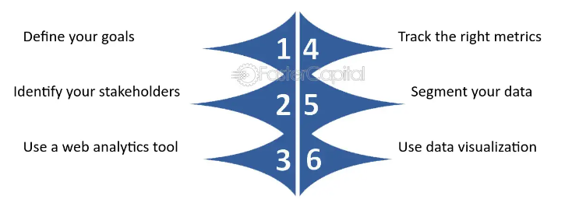

**Fig 17. Best Practices for Web Analytics.**

**Chapter 7: The Future of Web Analytics**

The landscape of web analytics is undergoing significant transformations driven by technological advancements, changing consumer behavior, and increasing regulatory scrutiny regarding data privacy. To thrive in this rapidly evolving environment, businesses must stay ahead of emerging trends and leverage innovative technologies. This chapter delves into these trends and technologies, offering actionable strategies for organizations to effectively navigate the future of web analytics.

**7.1 Emerging Trends in Web Analytics**

1. **Increased Focus on Data Privacy**
   * **Regulatory Compliance**: The enforcement of data protection regulations, such as GDPR in Europe and CCPA in California, is compelling organizations to reevaluate how they collect, manage, and utilize customer data. Non-compliance can lead to significant fines and reputational damage. As a result, companies must adopt practices that ensure they obtain explicit consent for data collection, clearly communicate their data usage policies, and implement robust data protection measures [10][12].
   * **Transparent Data Practices**: Building consumer trust is paramount in a privacy-conscious world. Organizations should be transparent about their data practices, offering users insights into how their information is collected and used. Implementing user-friendly privacy dashboards where consumers can view and manage their data permissions can enhance transparency and trust [14][12].
   * **Privacy-Centric Analytics Solutions**: The demand for analytics tools that prioritize user privacy is growing. Solutions that anonymize personal data or provide insights without exposing individual user information will become increasingly important. Businesses can leverage platforms that enable privacy-compliant tracking, ensuring compliance without sacrificing analytical insights [12][14].
2. **Integration of AI and Machine Learning**
   * **Advanced Data Analsis**: The application of AI and machine learning in web analytics enables businesses to analyze vast datasets more effectively. These technologies can identify complex patterns and correlations that traditional analytics may overlook. For instance, machine learning algorithms can enhance customer segmentation by analyzing various factors like browsing behavior, demographics, and purchase history [10][12].
   * **Personalization at Scale**: AI-driven analytics allows for real-time personalization of user experiences. Businesses can deliver targeted content and recommendations based on individual user behavior, significantly improving engagement rates. For example, e-commerce platforms like Amazon utilize AI to analyze user interactions and suggest products tailored to each customer’s preferences [12][14].
   * **Predictive Analytics**: By analyzing historical data, machine learning models can predict future behaviors and trends. Predictive analytics allows businesses to anticipate customer needs, optimize marketing campaigns, and improve inventory management. For example, a retail company can forecast which products will likely trend based on seasonal patterns and previous sales data [14][12].
3. **Real-time Analytics**
   * **Immediate Insights**: Real-time analytics empowers businesses to track user interactions as they happen. This immediacy allows for quick responses to customer behavior, such as adjusting marketing strategies based on live traffic data or addressing customer service inquiries in real-time [10][14].
   * **Agility in Decision-Making**: With real-time data, companies can make informed decisions quickly. For example, if a particular product is experiencing a spike in demand, businesses can immediately adjust inventory levels or launch targeted marketing campaigns to capitalize on the trend [12][14].
4. **Customer Journey Mapping**
   * **Holistic View of User Experience**: Mapping the customer journey involves tracking user interactions across multiple touchpoints, such as websites, social media, and email. This comprehensive approach allows businesses to identify drop-off points, optimize conversion funnels, and enhance the overall user experience [14][12].
   * **Segmentation and Targeting**: With insights from customer journey mapping, organizations can create more refined customer segments. Tailored marketing messages can be delivered to specific audience segments, ensuring that content resonates with their unique needs and preferences [10][12].
5. **Predictive Analytics**
   * **Behavioral Forecasting**: Predictive analytics leverages historical user data to forecast future actions. Businesses can identify trends in customer behavior and adjust their marketing strategies accordingly. For instance, predictive models can help determine which customers are likely to churn, enabling proactive retention efforts [10][14].
   * **Resource Allocation**: By understanding which products or services are likely to see increased demand, businesses can optimize inventory management and resource allocation. This approach ensures that companies meet customer needs efficiently while minimizing waste [14][12].

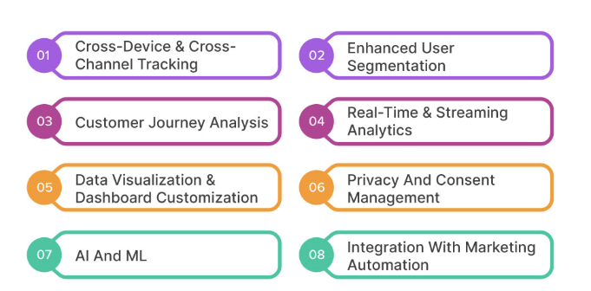

**Fig 18. Emerging trends for Web Analytics.**

**7.2 Technologies Shaping the Future of Web Analytics**

1. **Enhanced Data Visualization Tools**
   * **User-Friendly Interfaces**: Advanced data visualization tools offer intuitive dashboards and graphical representations of complex datasets. Businesses can utilize these tools to present data in formats like heatmaps, flow charts, and interactive reports, making it easier for stakeholders to interpret insights [10][14].
   * **Customizable Dashboards**: Companies can tailor dashboards to display specific metrics and KPIs relevant to different teams. Customization ensures that each department can access the information most pertinent to their goals, facilitating targeted decision-making [12][14].
2. **Cross-Channel Analytics**
   * **Integrated Insights**: Cross-channel analytics provides a unified view of customer interactions across various platforms. By integrating data from web, mobile, social media, and email campaigns, businesses can assess the effectiveness of their marketing strategies comprehensively [10][14].
   * **Attribution Modeling**: Understanding how different channels contribute to conversions is essential for optimizing marketing spend. Cross-channel analytics enables businesses to develop accurate attribution models, ensuring resources are allocated to the most effective channels [12][14].
3. **Voice and Conversational Analytics**
   * **Analyzing Voice Interactions**: As voice-activated technology gains popularity, businesses must analyze data from voice searches and interactions. Insights from voice analytics can help organizations understand how users engage with voice-activated devices, informing content strategies [12][10].
   * **Chatbot Analytics**: With the rise of chatbots for customer service, analyzing interactions within these conversational interfaces is crucial. Businesses can leverage chatbot analytics to assess user satisfaction, identify common inquiries, and improve response quality [10][14].
4. **Augmented and Virtual Reality Analytics**
   * **Data from Immersive Experiences**: As AR and VR technologies expand, businesses will need to analyze user interactions within these immersive environments. Collecting data on user engagement with AR and VR content can inform marketing strategies and product development [10][12].
   * **Enhanced Customer Engagement**: Understanding user behavior in AR and VR can help businesses create more engaging experiences. For example, retailers can use AR to allow customers to visualize products in their own spaces, increasing purchase confidence and satisfaction [14][12].
5. **Blockchain Technology**
   * **Secure Data Management**: Blockchain technology offers a decentralized and secure method for managing user data. By utilizing blockchain, businesses can enhance data integrity, ensuring that customer information is stored securely and can be trusted by users [14][12].
   * **Smart Contracts for Data Usage**: Implementing smart contracts on blockchain can automate data consent management, ensuring that user permissions are respected. This capability enhances compliance with privacy regulations and builds trust between businesses and consumers [12][14].

**7.3 Preparing for the Future**

To effectively navigate the future of web analytics, businesses should consider the following strategies:

1. **Invest in Advanced Analytics Tools**
   * **Adopt AI-Driven Solutions**: Prioritize investments in analytics platforms that leverage AI and machine learning for enhanced data analysis and insights. Tools that offer predictive capabilities can significantly improve decision-making processes [10][14].
   * **Scalability**: Choose analytics solutions that can grow with the business as data volumes increase and analytics needs evolve. Scalable platforms will allow organizations to adapt to changing market conditions and consumer behaviors [12][14].
2. **Embrace a Data-Driven Culture**
   * **Training and Education**: Invest in training programs that equip employees with the skills necessary for data analysis and interpretation. A data-driven culture encourages informed decision-making and fosters innovation within the organization [12][14].
   * **Cross-Department Collaboration**: Promote collaboration between marketing, sales, and IT departments to ensure that data insights are shared and leveraged effectively across the organization. Collaborative efforts can enhance the overall effectiveness of marketing strategies [10][14].
3. **Prioritize Data Privacy and Compliance**
   * **Robust Data Governance Policies**: Implement strong data governance frameworks that outline data collection, usage, and storage practices. Regular audits and updates will help ensure ongoing compliance with evolving regulations [12][14].
   * **User Education**: Educate users about how their data is used and provide clear, accessible privacy policies. Transparency regarding data usage builds trust and encourages user engagement [10][14].
4. **Focus on Customer Experience**
   * **User-Centric Design**: Utilize analytics to inform user experience design, ensuring that websites and applications are intuitive and meet customer needs. A seamless user experience can significantly impact customer satisfaction and retention [12][14].
   * **Feedback Loops**: Establish feedback mechanisms, such as surveys or user testing, to gather insights into customer satisfaction and areas for improvement. Continuous feedback helps businesses adapt to changing consumer expectations [10][14].
5. **Stay Informed on Industry Trends**
   * **Continuous Learning**: Encourage employees to stay updated on emerging trends and technologies in web analytics. Participation in industry conferences, webinars, and online courses can provide valuable insights and networking opportunities [12][14].
   * **Networking**: Building connections with industry peers allows organizations to share best practices and learn from each other's experiences. Networking can foster innovation and collaboration within the analytics community [10][12].

be essential for success in the coming years. By staying informed and adaptable, businesses can not only survive but thrive in the dynamic world of web analytics.  
 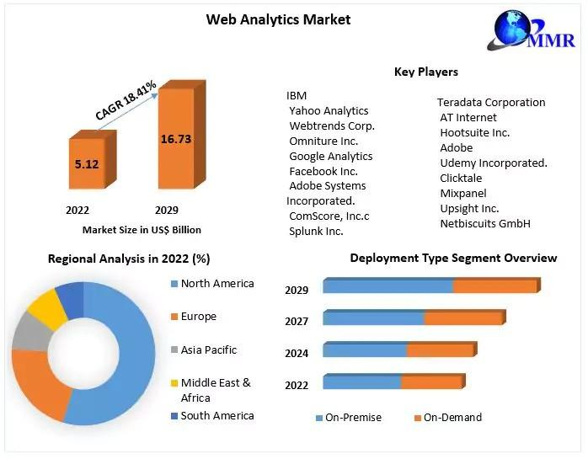

**Fig 19. Web Analytics Market Growth Revenue.**

### Conclusion

Web analytics has evolved into an indispensable tool for businesses striving to excel in today’s digital-first world. What started as a basic method for tracking website traffic has now transformed into a sophisticated process, enabling organizations to gain valuable insights into user behavior, optimize site performance, and refine their digital marketing efforts. By employing the right web analytics tools, businesses can capture vast amounts of data that, when analyzed correctly, reveal patterns and trends that are critical to improving user experience, increasing conversion rates, and maximizing return on investment.

Moreover, the correct implementation of web analytics tools allows businesses not only to monitor their website’s performance but also to make informed, data-driven decisions that shape their overall digital strategy. The ability to track key performance indicators (KPIs) such as bounce rates, session durations, conversion paths, and more, gives organizations the power to tailor their online offerings to better meet the needs of their audience. This level of understanding fosters an iterative approach where websites and campaigns are continuously refined and improved, leading to greater customer satisfaction and business growth.

However, the future of web analytics promises even greater possibilities. With the rise of AI and machine learning, businesses are beginning to automate data analysis and derive insights with unprecedented accuracy and speed. These technologies will soon be essential for processing real-time analytics, predicting future trends, and enabling businesses to respond proactively to market shifts. At the same time, privacy concerns are driving a rethinking of how data is collected and used, pushing companies to adopt more transparent and ethical practices.

In addition, cross-channel analytics is emerging as a powerful tool, enabling organizations to unify data from various platforms—social media, mobile apps, email, and more—into one cohesive view. This approach not only provides a holistic understanding of customer interactions across all digital touchpoints but also enables the optimization of multi-channel marketing efforts.

Businesses that embrace these advancements and invest in cutting-edge tools while prioritizing user privacy and ethical data use will be better positioned to succeed. By fostering a culture of continuous analysis and optimization, these organizations will remain agile in a rapidly changing market. In conclusion, web analytics is not just a tool for tracking online metrics; it is a strategic asset that, when used effectively, can drive sustainable business growth, improve customer experiences, and secure a competitive edge in the ever-evolving digital landscape.

**References**

1. Spiceworks. (n.d.). Top 10 web analytics tools to help businesses track and improve their site performance. Retrieved from <https://www.spiceworks.com/tech/devops/articles/web-analytics-tools/>
2. TechTarget. (n.d.). What is Google Analytics? Definition and history. Retrieved from <https://www.techtarget.com/searchbusinessanalytics/definition/Google-Analytics>
3. GoSquared. (n.d.). Features. Retrieved from <https://www.gosquared.com/features/>
4. Hotjar. (n.d.). Top 10 web analytics tools for your business. Retrieved from <https://www.hotjar.com/web-analytics/tools/>
5. Mixpanel. (n.d.). Product releases. Retrieved from <https://mixpanel.com/product-releases/>
6. Growth Natives. (n.d.). Top 15 web analytics tools every business needs. Retrieved from <https://growthnatives.com/blogs/web-analytics/web-analytics-tools/>
7. Woopra. (n.d.). Best web analytics tools for businesses. Retrieved from <https://www.woopra.com/blog/best-web-analytics-tools>
8. Kissmetrics. (n.d.). 10 Web analytics tools you should consider. Retrieved from [https://kissmetrics.com/](https://kissmetrics.com)
9. Piwik PRO. (n.d.). Top 12 web analytics tools you should try in 2024. Retrieved from <https://piwik.pro/blog/best-web-analytics-tools/>
10. Crazy Egg. (n.d.). What is web analytics? Retrieved from <https://www.crazyegg.com/blog/what-is-web-analytics/>
11. Adobe Analytics. (n.d.). What is Adobe Analytics? Retrieved from <https://www.adobe.com/analytics/adobe-analytics.html>
12. Heap. (n.d.). Heap Analytics: Capture every user interaction. Retrieved from [https://heap.io/](https://heap.io)
13. Matomo. (n.d.). Matomo Analytics: The leading open-source web analytics platform. Retrieved from [https://matomo.org/](https://matomo.org)
14. Segment. (n.d.). Customer Data Platform - Segment. Retrieved from [https://segment.com/](https://segment.com)
15. Clicky. (n.d.). Clicky Web Analytics - Real-time Web Analytics. Retrieved from [https://clicky.com/](https://clicky.com)
16. Fathom Analytics. (n.d.). Privacy-focused web analytics. Retrieved from [https://usefathom.com/](https://usefathom.com)
17. StatCounter. (n.d.). Free web analytics and tracking. Retrieved from [https://statcounter.com/](https://statcounter.com)
18. Nifty. (n.d.). Nifty Analytics: Visualize your website’s performance. Retrieved from [https://niftypm.com/](https://niftypm.com)
19. Analytics Mania. (n.d.). Google Tag Manager: The Definitive Guide. Retrieved from [https://www.analyticsmania.com/](https://www.analyticsmania.com)
20. WebFX. (n.d.). Web Analytics: What Is It & Why Is It Important? Retrieved from <https://www.webfx.com/blog/marketing/web-analytics/>